**Boolean Toggle**

**LightOnActive.x3d**

Example of NOT having the Boolean Toggle. A light comes on when we are over the red cylinder, but will not stay on after we roll off the red cylinder.

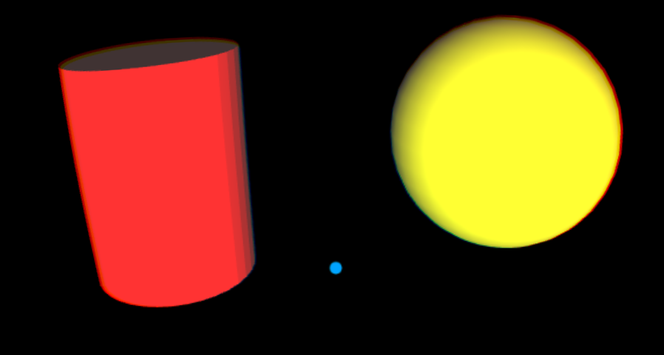

**BooleanToggle_IsActive_LightOn.x3d**

Similar demo to above, but now the light stays on after tapping the red cylinder, and stays on until it is tapped again.

**BooleanToggle_IsOver_LightOn.x3d**

Similar demo to above, but now the light stays on after the icon is over the red cylinder, and stays on until it is the icon is over the red cylinder again.

**BooleanToggle_IsActive_MultipleLightsOn.x3d**

A red, green and blue Cylinder turns on a red, green and blue point light respectively.

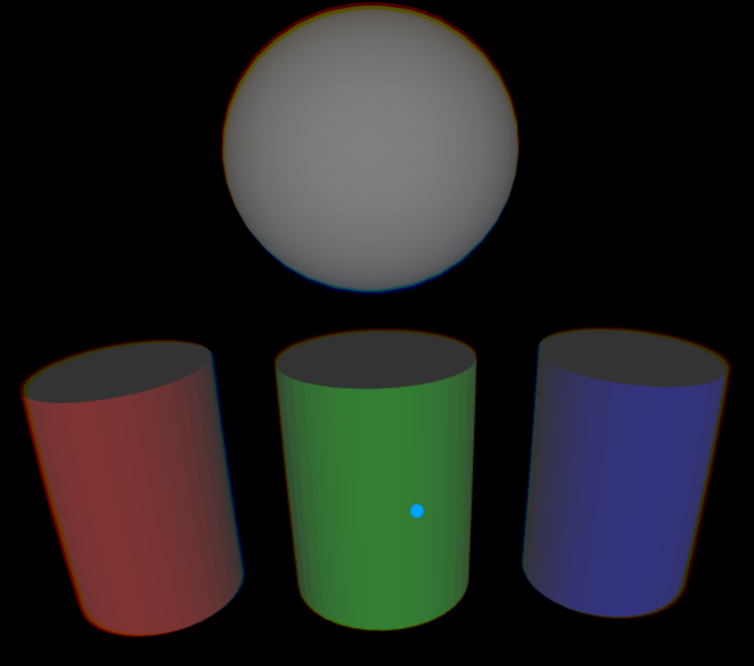

Below shows the green and blue Cylinders have been tapped turning on those point lights. The red point light is on the left, the green point light is in the center and the blue point light is on the right.

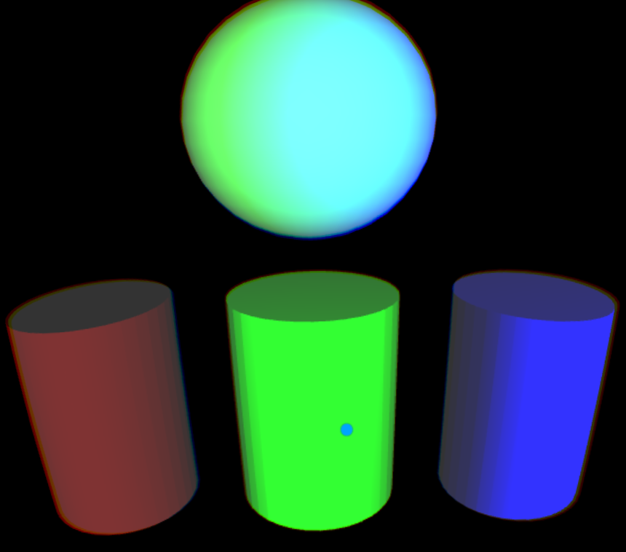

**BooleanToggle_IsOver_MultipleLightsOn.x3d**

Similar to the above demo, but now the icon just being over the Cylinders turn those point lights on and off, instead of tapping / clicking on the Cylinders.

**BooleanToggle_IsActive_MultipleLightsOn2.x3d**

A gray bar has been added below that turns on/off all three lights. Note that clicking on a Cylinder after the gray bar may not turn off that light as the lights are now controlled by two distinct, independent BooleanToggles. It’s as if there were two separate light switches controlling the same light.

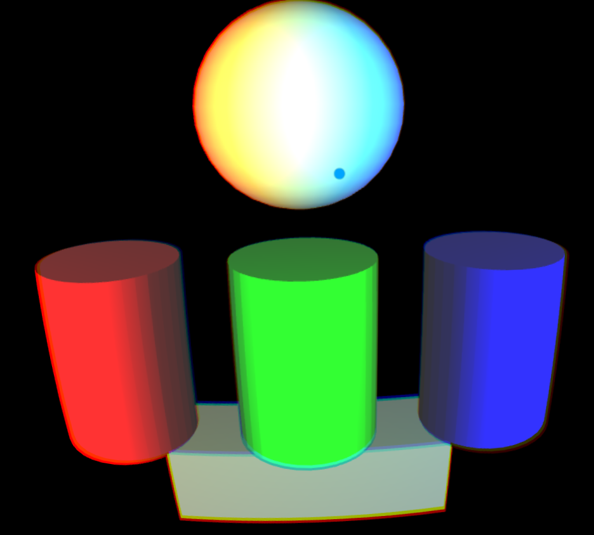

**BooleanToggle_IsOver_MultipleLightsOn2.x3d**

Similar to the previous demo, but now lights turn on/off when the icon over the Cylinders or Gray Bar.

**BooleanToggle_Mixed_MultipleLightsOn.x3d**

Demonstrates animated objects while using the same TouchSensor to control animation and BooleanToggles.

The top sphere is in continuous rotation around the x-axis. The middle sphere rotates around the y-axis when the icon is rolled over the left gray bar. The bottom sphere rotates around the z-axis when the right bar is tapped / clicked.

**.**

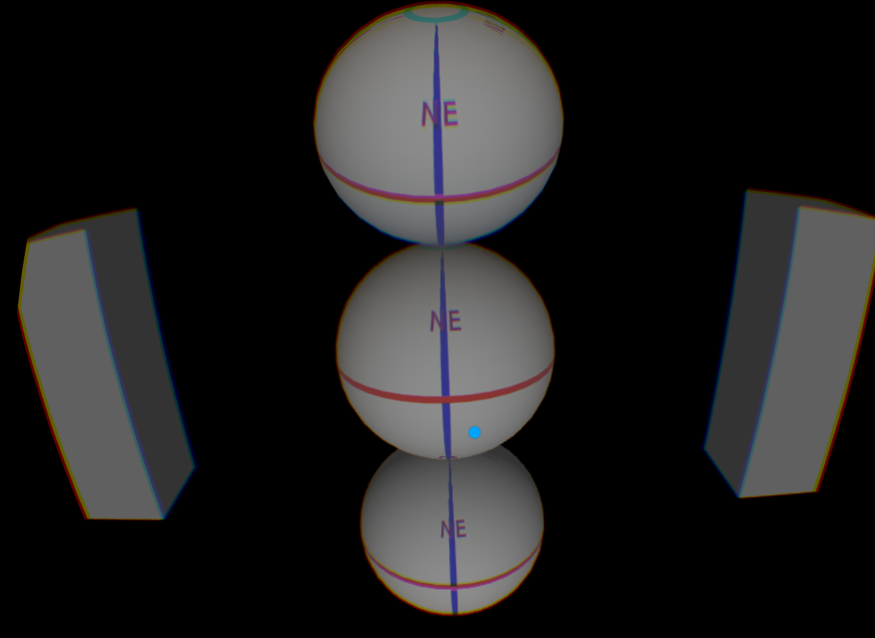

The gray bars on the right and left also turn on a red, green and blue spot light. The spot lights on the left have increasing beamWidth’s from top to bottom (Note the small red circle on the left of the top sphere). The spot lights on the right have decreasing beamWidth’s from top to bottom (Note the small blue circle on the right of the bottom sphere).

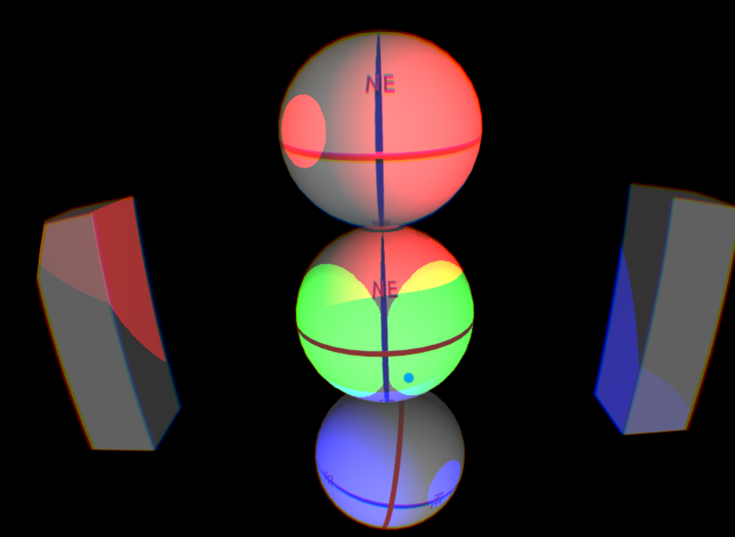

**buttonDemo02.x3d**

This demo has 3 buttons – red, green and blue – that simulate depressing and turns on/off each color in the scene. There is also a rotate button that depresses while rotating the Sphere 360 degrees around the y-axis.

